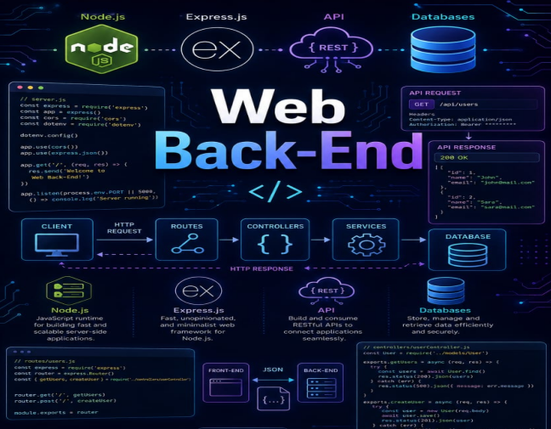

Web Back-End

By Jawad Jammoul

